Want to modify program UMCATE00

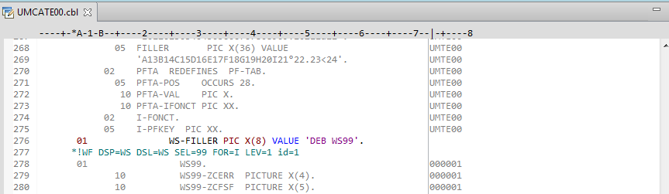

Modify WS-FILLER value

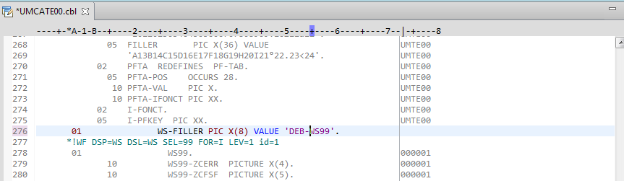

Then save

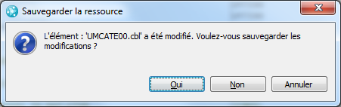

Date compiled hasn’t changed

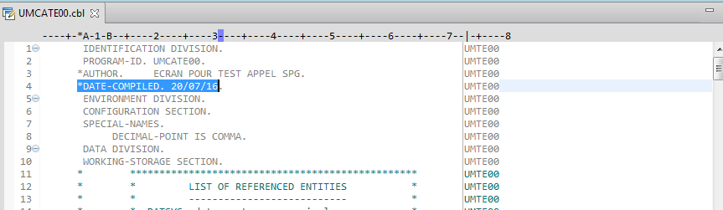

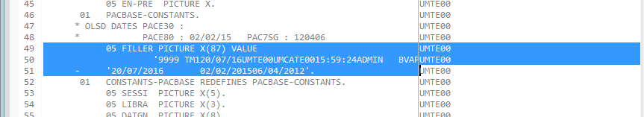

To change the date compiled, we must generate the cbl (ALT G)

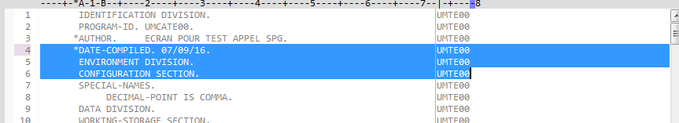

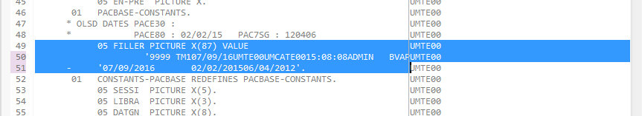

Is there a way in the preferences to automatically change the date compiled when the program is modified?

