**Search with cross-reference key in Input Aid’s –D Lines tab**

In RPP, search for the instances that contain the key “AUTEUR” in Input Aid “REMONT” :

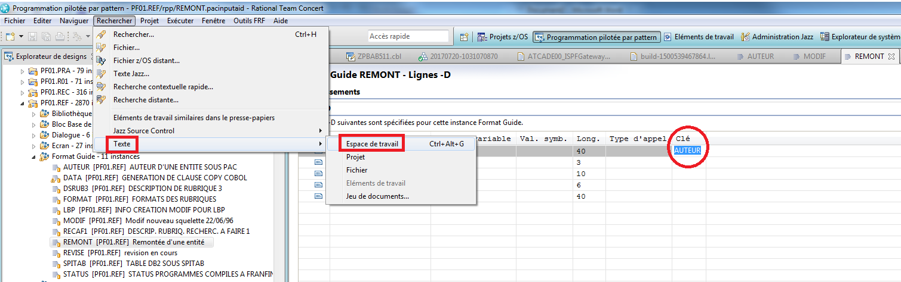

The search result doesn’t have details as PACBASE does.

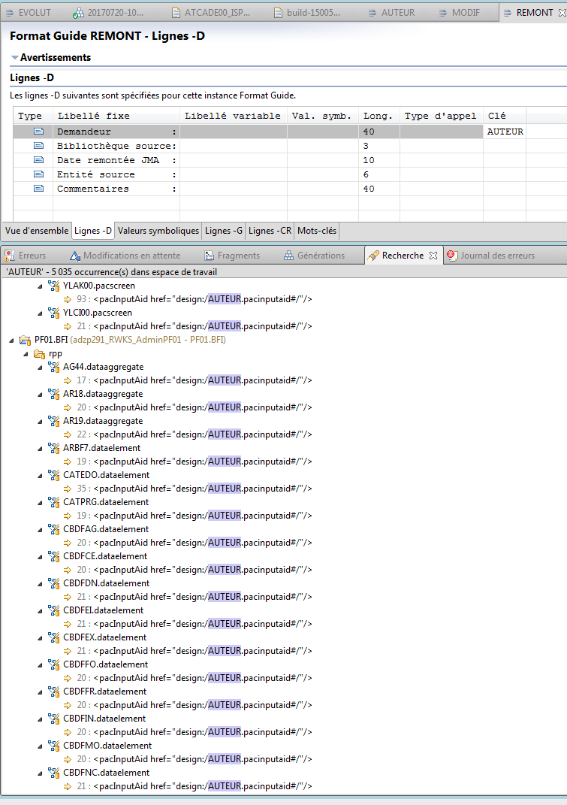

With the command “XIAUTEURIREMONT” in PACBASE, we have a better result, with details (value entered in variable part):

