IBM CL/SuperSession Support for CV64 at Ingram Micro

Author: Russ Teubner, HostBridge Technology (on behalf of Ingram Micro)

Date: 12/21/20

# Overview

When a TN3270 connection is established directly to a CICS region, CICS can determine the ip address/port of the client. CICS obtains this information from Control Vector x’64’ (CV64), which TN3270 Server creates and passes to the VTAM application (Control Vectors are chained off the CINIT RU). This TN3270 client info. (referred to as the “TNADDR” info) is then known by CICS and included in the SMF 110 performance class records created by CICS (e.g., fields CLIPADDR and CLIPORT). Having this information for all TN3270 sessions is imperative for many reasons -- including the need to attribute transaction/macro activity as closely to the source as possible.

# The Problem

When a TN3270 session goes through CL/SuperSession (CLSS) CICS does NOT receive a CV64 and thus doesn’t know the IP address/port of the client. As a result, the SMF 110 record does not include the TNADDR info.

# Background

The “invention” of CV64, and its support by TN3270 Server and various VTAM apps, goes back to 2010, and z/OS v1.12. The following IBM slide is from that era:

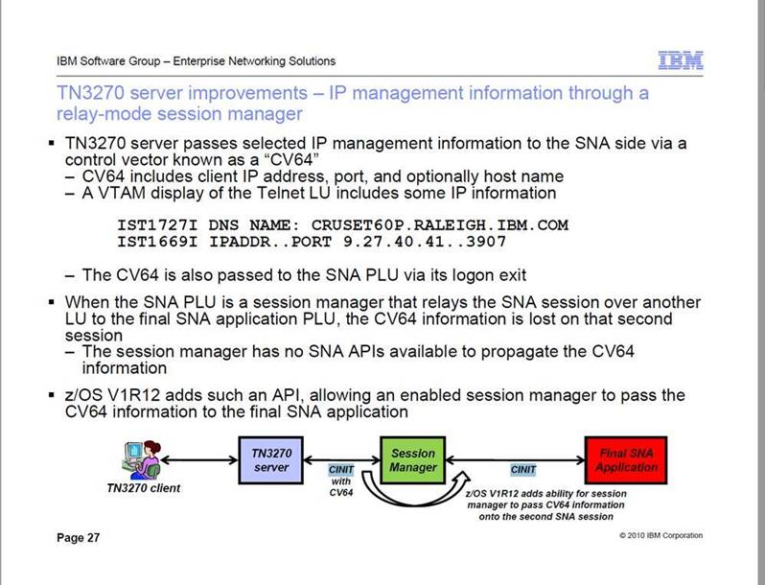

The slide outlines the information “gap” that can occur if the TN3270 connection goes through a session manager. To solve this, IBM created the necessary APIs to allow an “enabled” session manager to receive and pass the CV64 information to the final SNA application.

Research indicates that IBM did support CV64 in the “IBM Session Manager” - the session manager sold by IBM prior to standardizing on CL/SuperSession (CLSS). However, based on our testing (and the CLSS documentation) we find no evidence that CLSS supports passing CV64 to the final VTAM app. Thus, we assume that CLSS was never enhanced to be “CV64 enabled”.

# Non-Solutions

Somewhere along the way, CLSS was enhanced to save the IP address in CLSS panel variables KLSIP and KLSPORT. While this gives some hope that CLSS might at least be detecting CV64 when a TN3270 client logs in, having this info in CLSS variables is of little/no value. Here’s why…

It is NOT our intent to create a home-grown technique to pass the value of these CLSS variables to CICS as customer-specific “userdata”. We (Ingram) would need to create/modify CICS auto-install exits to support such a home-grown technique. Furthermore, it makes no sense to use this approach given that (a decade ago) IBM created a standard technique to handle the convenance of the TNADDR info. via CV64.

# Call Objectives / Requests

We request a phone call with someone on the CL/SuperSession development team. During this call we would like to know, authoritatively, whether CLSS was ever enhanced to be “CV64 enabled”, per the diagram on the IBM slide. In other words, can CLSS be configured to pass CV64 to the final VTAM app (e.g., CICS)? If so, we want to know how.

And, if the answer is “no”, we would like to discuss/define a RFE for IBM to make CL/SuperSession an “CV64 enabled” session manager (as described in the IBM slide).