Zunit – Result of testcase correct V2

Hi all,   
  
I’m sorry to inform you that I’m not able to re-create my described issue anynmore with program DXXT1. After installing maintenance update the program DXXT1 is going into a loop. No reason yet found !

Lucky for us, I’m able to create the issue with another program DXXT0 !

DXXT0 is a simple batch program that based on the PRM-FAMNaam of inputdataset INPARM selects all records from inputdataset INBSD51 and writes the selected records to outputdataset UTBSD51.

It’s a remote project we use here

So we want to select all records with FAMNM = PRIEM

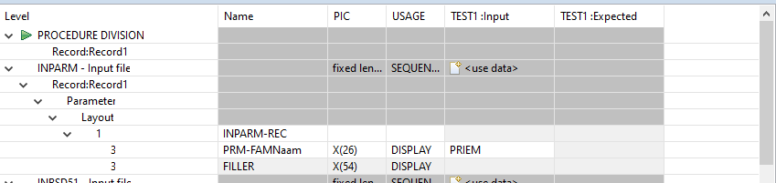

Out of these 2 input records

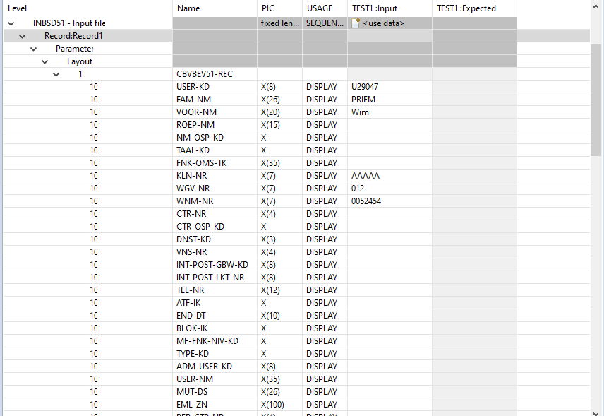

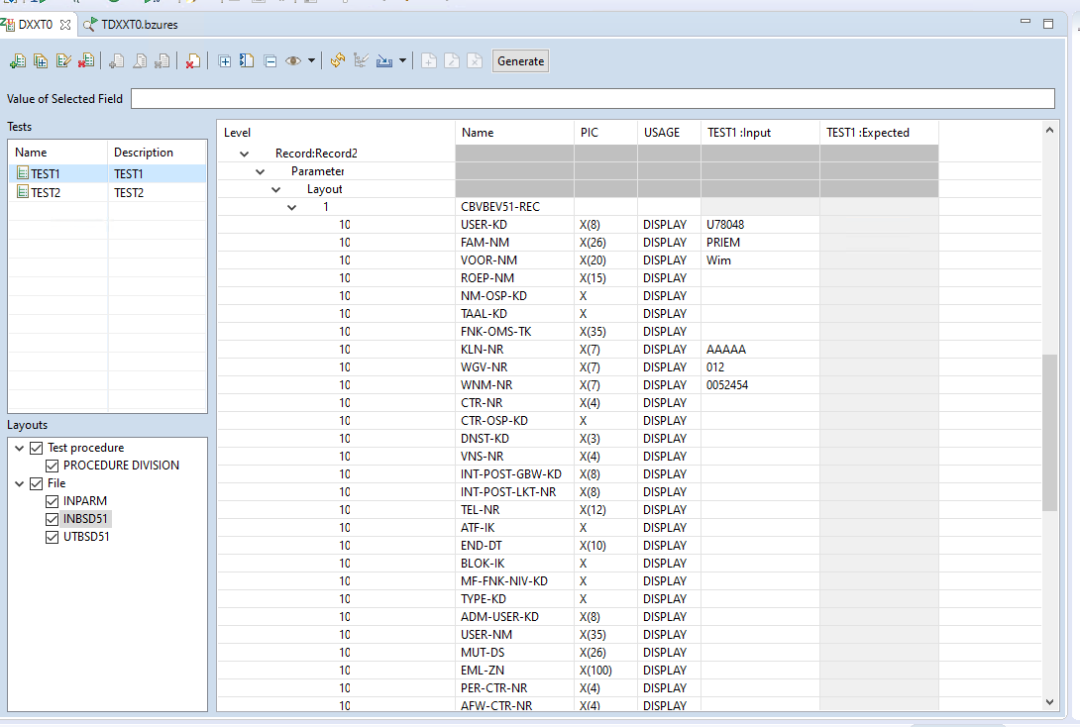

Described output

For test 1



For test 2

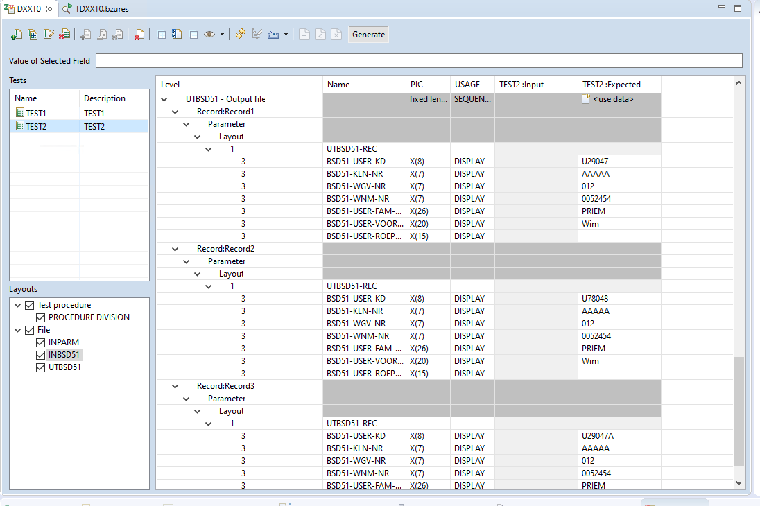

TESTRESULT

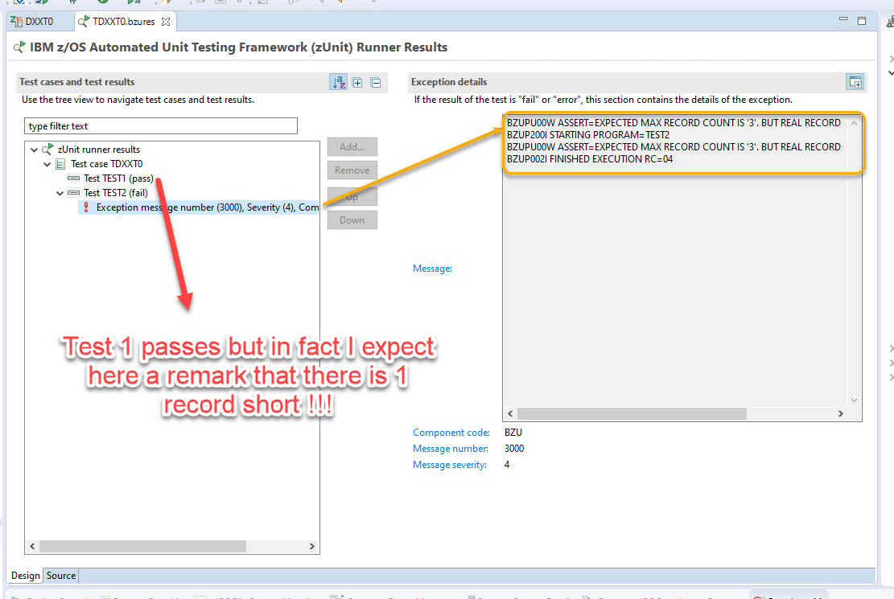

Created INBSD51 in testcase

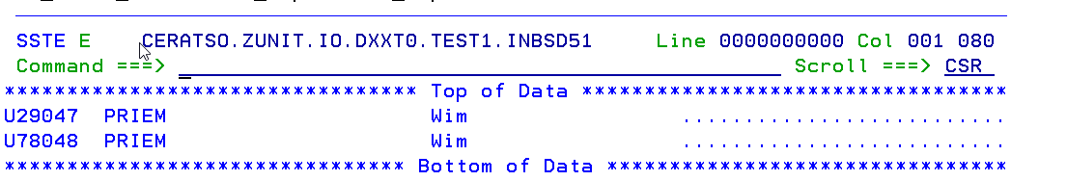

Created outputfile in testcase

