An important feature of LPEX is missing in the COBOL editor: The Start Flagging changed line is not available. We're using this functionality to automatically mark the first 6 columns of the COBOL program.
We would need this functionality in the COBOL editor also.

The "COBOL marking" the first 6 columns is important to indicate (and return) the changes made ​​at some point.
In the example below, we find in the line 904 why the program has been commented out, and by whom.
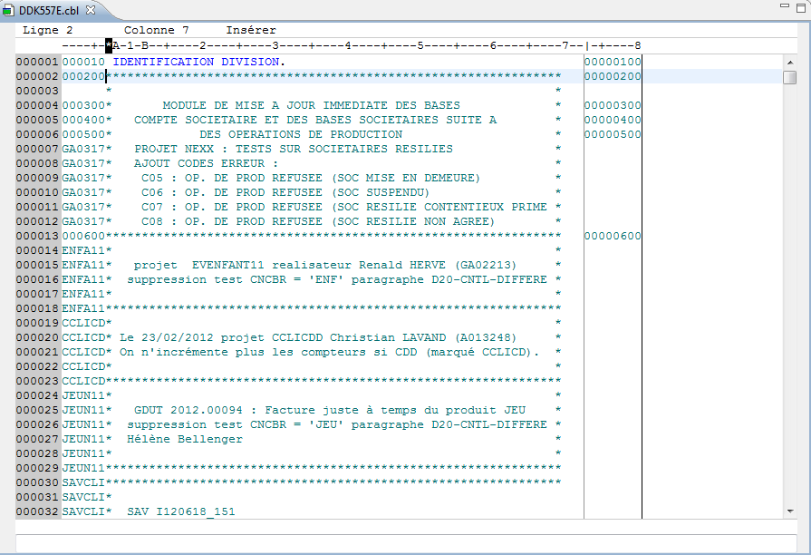
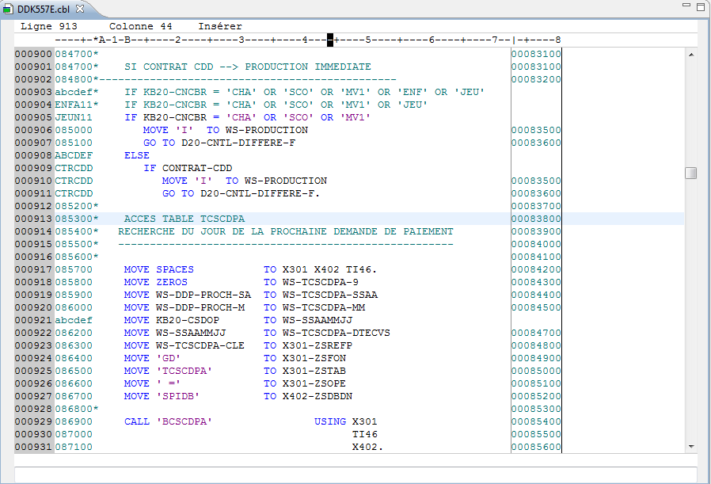
We set it in the editor autotagging LPEX, in the "automatic comment" preferences (see document " How to start flagging in COBOL.doc").
For the trigger, just click on "start marking changed lines" to choose and mark the first 6 characters.
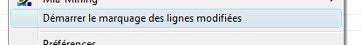

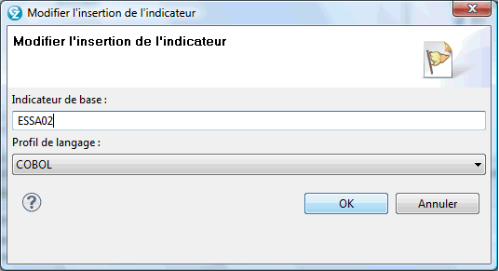

Then, each line is modified automatically generating a mark in its first 6 characters.

Before Change :

After Change :

We need to have this cool feature available in COBOL editor.
Thank you for your help.

