In 8.0.3, When I search for a string in RSE. It does not display the searched files but instead it displays **<selected resources>**. I am unable to verify which files and/or PDS’s it has searched against in the GUI. Also If I save the search query and I come back to it, I can’t see what files/PDS’s the search query was executed on. Is this corrected in v8.5?

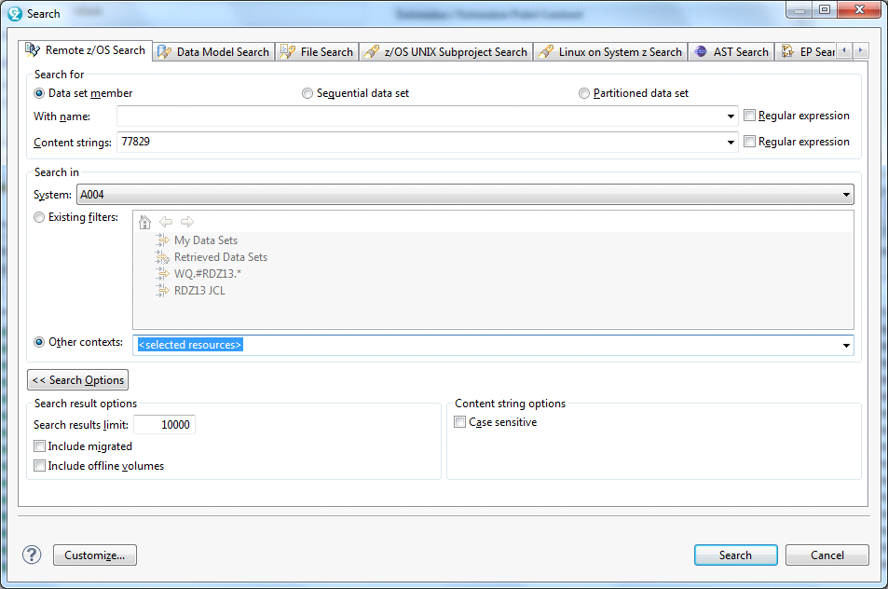

Previous RDz version which showed the datasets. See **Search in** below.

