**JES REDESIGN**

**Here below are few features to be considered for JES Redesign**

1. RFE 30046 - Option to save a ddname into a file (TSO/Local)
2. RFE 29336 - Date filter
3. RFE 30076 - Sort by Date within JES in Remote Systems view – need option to right click and select to SORT OPTION 🡪 sort by date, owner id, job id, return code, etc

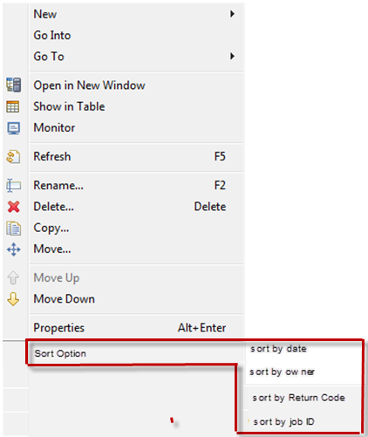

1. RFE 30077 - Return Code with job in JES in Remote Systems view – today we see job name and job id. We need to see the Job return code in JES in RSE view.

Return Code Value:Job Name:JobID

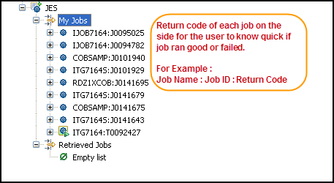

1. RFE 30078 - Return Code for each step in Remote Systems view - We need to see the return code for each step in JES in RSE view.

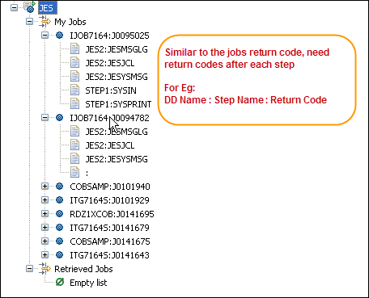

1. RFE 30079 - Which step is currently being executed – Today we see all the steps.  We need some indication of which step is currently executing.

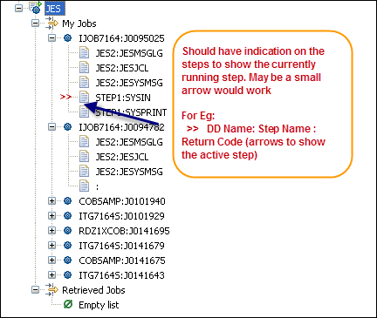

1. RFE 30080 - Navigation through job dd outputs (next/previous).  Today we view the contents of a ddname in JES Job.  Once we are in the ddname, we need some way to go to the next or previous ddname automatically.

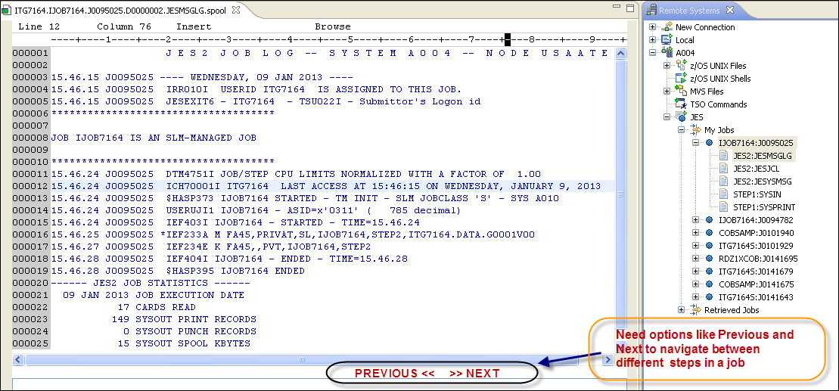

1. RFE 15183 - Job Summary and Step Details

JES should have Job Summary and Step Details. This can be used in the “Remote Systems Detail” view currently being used as “Monitor” for the jobs which also permits the user to “Go Into” more detail in the job.

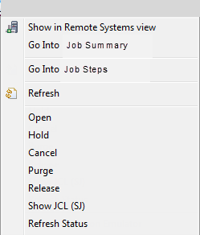In the “Remote Systems Details” view, the jobs are listed and we can right click and select “Go Into” to dive into the ddCards for the job.

We would like to see two “Go Into” options when you right click:

* Go Into Job Summary
* Go Into Step Details

With Job Summary displaying in column format:

* Return Code of each Step
* Step Name
* Procedure Step
* Procedure
* Comment

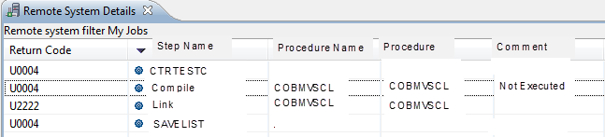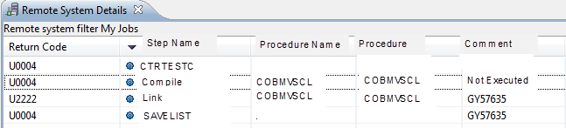

RFE 15183 - Job Summary and Step Details, continued.

With the Step Details displaying in column format:

* DD Card Name
* Step ddCard is in
* Procedure Name
* Status
  + Busy = being processed
  + Held = Held output
  + Done = Processing complete (Printing, etc)
* Size (in number of lines/rows)

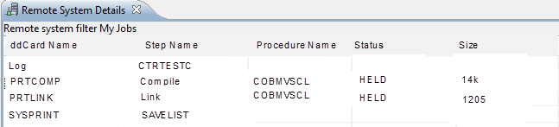

1. RFE 30081 - All executing JES jobs list at top of filter.  Today the executing jobs are at the bottom.  We need a way to filter them to the top of the stack. We need a way of setting the display order for the different types of jobs (input jobs/running jobs/output jobs).

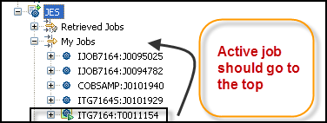

1. RFE 29337 - Faster response loading list of output jobs (from filter)
2. RFE 30082 - Right click in JES to re-submit job (no Show JCL).  Today we have SHOWJCL in JES and then have the option to Re-submit.  This is a 2-step process.  We need the option to right click and submit in JES RSE thereby bypassing SHOWJCL.

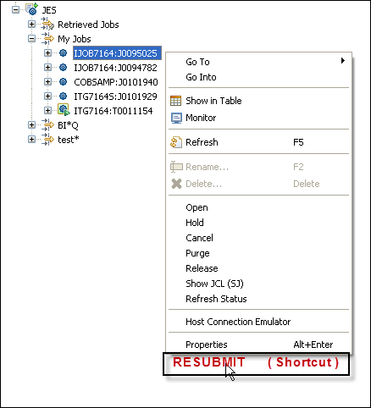

1. RFE 30083 - Pop-up/Alert when job is completed.  Today we have to refresh or set poll configuration to refresh the JES job status.  We need an alert msg similar to RTC alerts that the job has completed and the option to suppress the alerts if the user chooses.