

Enterprise Modernization
Pacbase – Rational Programming Patterns Convergence at General Motors
Endevor Integration Design

Version of April 15th, 2015

Table of Contents
Enterprise Modernization 1
1. Goal 3
2. Current Environment Detail 4
3. System Definitions & Endevor Parameters 5
3.1. z/OS mainframe 5
3.2. Endevor Instance, Environment, System, Subsystem 5
3.3. Type/Processor Group 8
3.4. Translators 8
3.4.1. Generation of Mask Code for GM*Drive: 9
3.5. CCID 10
3.6. Comments 10
3.7. Additional parameters 10
3.8. Rexx scripts 12
4. Association of a Language Definition 14
4.1. With command line interface 14
4.2. With RPP/RTC workstation 14
5. Build Example 17
5.1. Build Request 17
6. Annex A : Types/Processor Groups 23
6.1. GM*Drive 23
6.2. COP 23
6.3. AAS 23
6.4. COST (Finance) 23
6.5. CF (Corporate Functions) 24
6.6. VTIMS 24
6.7. GCOMS 24

Goal
This document is the deliverable of the following task described in the DOU:

5.3 Assess and Design the solution for integration with CA Endevor

It describes the process to set in place for General Motors to manage the integration between RTC and Endevor.

The General Motors applications in the scope of the integration are

GM*Drive Repository PK01 for Development and PK02 for Production

COP Repository PK03 for Development and PK05 for Production

AAS Repository PK03 for Development and PK05 for Production

COST Repository PC12 for Development and Production

CF Repository PC12 for Development and Production

VTIMS Repository PC12 for Development and Production

GCOMS Repository PC12 for Development and Production

Current Environment Detail
Application | Mainframe | LPAR | Endevor  Instance | Environment | System | Sub-System | Stage | Types
GM*Drive | RUIPC2W | RA00  RB00  RC00 | $C1DFT2W | DEA#TEST | DEAA | DRE  KSD | 2 (Test) | See Annex A
COP | RUIPC2W | RA00  RB00  RC00 | $C1DFT2W | DEA#TEST | DEA6 | A8A  A9A | 2 (Test) | See Annex A
AAS | RUIPC2W | RA00  RB00  RC00 | $C1DFT2W | DEC#TEST | DECG | CYE | 2 (Test) | See Annex A
COST  (Finance) | PLIPC1A  (P102,P103) | P102  P103 | $KGMCKGC | KGMCTEST | KA33KRH  KA11KAD | X  D2PI | T (Test) | See Annex A
CF  (CORP) | PLIPC1A | P102  P103 | $KGMCKGC | KGMCTEST | KA12KPR  KA51KHP | X  D2P1 | T (Test) | See Annex A
VTIMS | PLIPC1B | P105  P107 | $SMPASPA | SMPATEST | SMLGLVV | X | T (Test) | See Annex A
GCOMS | PLIPC4B | P403  P404 | $MGO1MGO | MGO1DEV2 | MGO1MGO | COMS | C(FIXD2) | See Annex A

System Definitions & Endevor Parameters

z/OS mainframe
We define at least one Build Engine per application. The Build Engine contains the Hostname of the target system where Endevor and the Rational Build Agent are running.
We can define more than one Build Engine per application in order to have parallel Builds.
These Build Engines are defined in the Administration Project Area
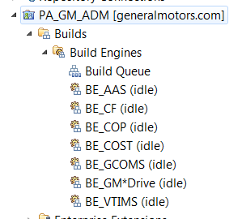

Endevor Instance, Environment, System, Subsystem
We define 2 Build Definitions per Endevor instance/Environment/System/Subsystem, one for Development Stream, one for Production Stream.

Endevor instance, Environment, System and Subsystem are properties of the Build Definition.

Below an example of the combinations we have, based on what is used for each application.

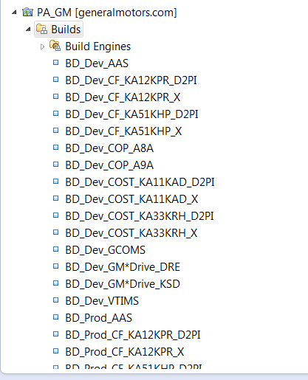

With the following property dedicated to the Build Definition. Example

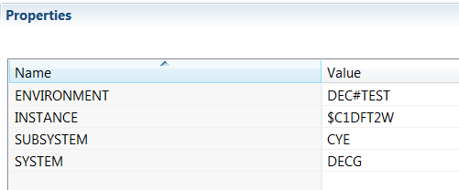
These parameters can be changed if needed when we request a Build

Build Engine are associated to the Build Definition, ex:
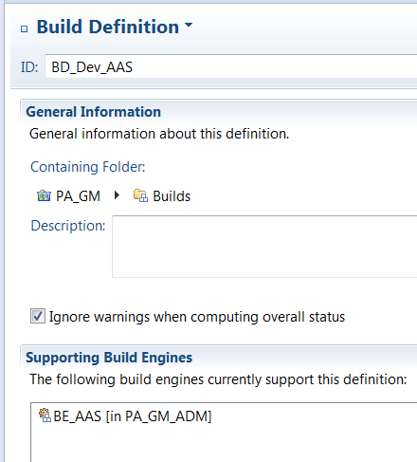

The Build Engine is configured with a Dummy User, in order to force the user to enter his credentials, so the build will be ran under the developer’s authority
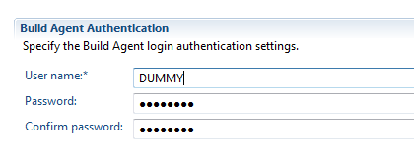
To avoid to make the Build Engine inactive as we have a dummy user, ‘Monitor the last contact time’ has been unchecked.

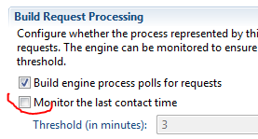

Type/Processor Group
We define 1 Language Definition per Type/Processor Group

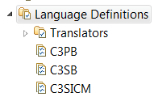
With the following variables defined on the Language Definition. Below an example
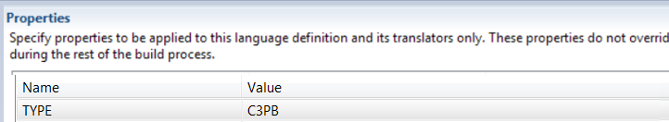

Translators
We define one single translator. The purpose of the translator is to:
- Build an Endevor JCL with the appropriate parameters
- Run this JCL
- Examine the return code of the JCL, and upload the Build Log of RTC with the Jobname, Jobnumber and return code;

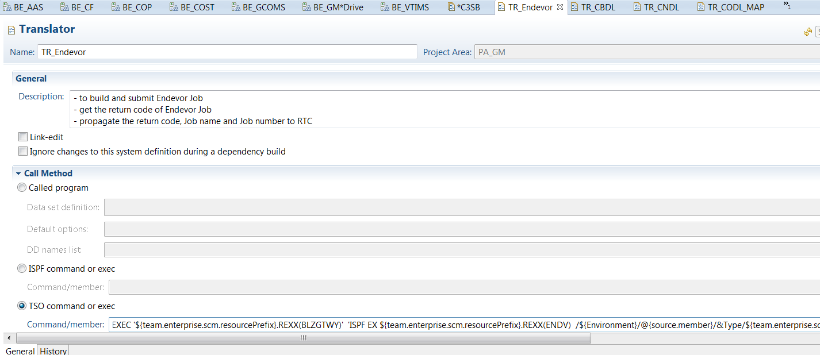

The TSO command of the Translator looks like below:
exec 'TMGO1.MGOCM.TEST.EXEC(BLZGTWY)' 'ISPF EX TMGO1.MGOCM.TEST.EXEC(endv)
/@{source.member}/${team.enterprise.scm.resourcePrefix}/${INSTANCE}/${ENVIRONMENT}/${SYSTEM}/${SUBSYSTEM}/${TYPE}/${CCID}/${team.enterprise.scm.snapshotId}/${DEBUG}/${OVERRIDESIGNOUT}/${SCHENV}/${ITEST}/'

The translator is called in the Language Definition, like below:
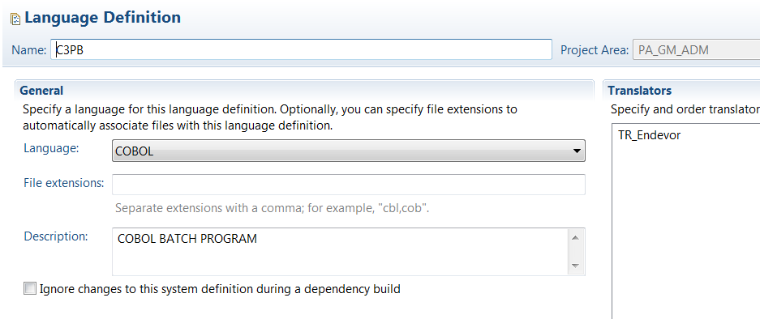

Generation of Mask Code for GM*Drive:
There is a specific process for the Generation of MAPs for GM*Drive.
Mask Code is handled via separate functionality due to changes to Mask code. Final result (after DREPMON1/2) is put into TDEAA.DREUF.MAP
We define a translator dedicated to the generation of MAP for GM*Drive
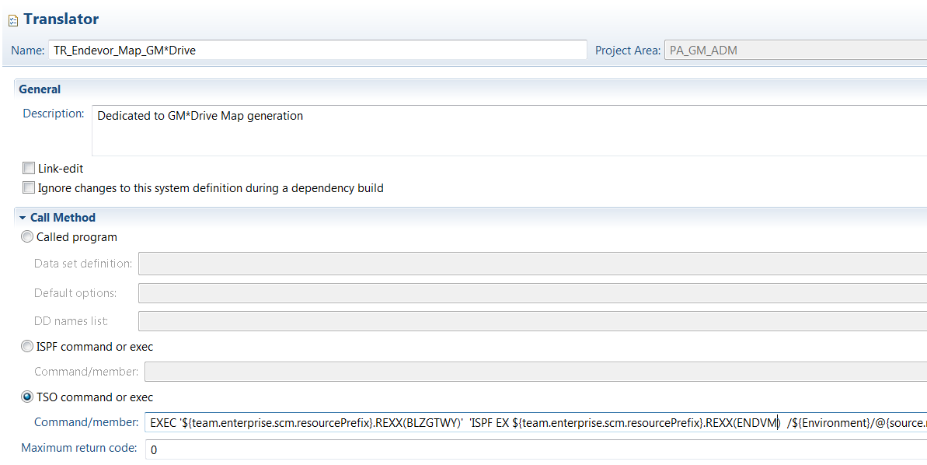

This translator will be called in the appropriate Language Definition for GM*Drive map generation
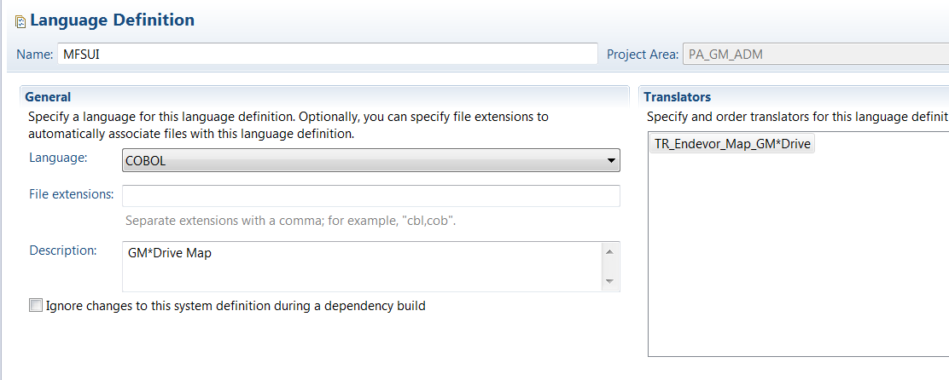

CCID
CCID parameter is used as a comment

We propose to setup the RTC Userid

Comments
We propose to setup the Comments parameter with the name of the Snapshot taken during the Build

In case of Personal Build, Comments are setup with label ‘PERSONAL BUILD’

Additional parameters
- options may be used for ADD action:
- Option for debugging
This option generates in bold
OPTIONS CCID 'PACBASE' COMMENTS "RTC ADD" PROC GROUP 'ITEST'
- Override sign-out and update if present
This option generates in bold
OPTIONS CCID 'PACBASE' COMMENTS "RTC ADD" OVERRIDE SIGNOUT UPDATE

ITEST may have values ITEST, INTRTST, and any additional value
We propose to manage these 2 options as 3 properties in the Build Definition, as below
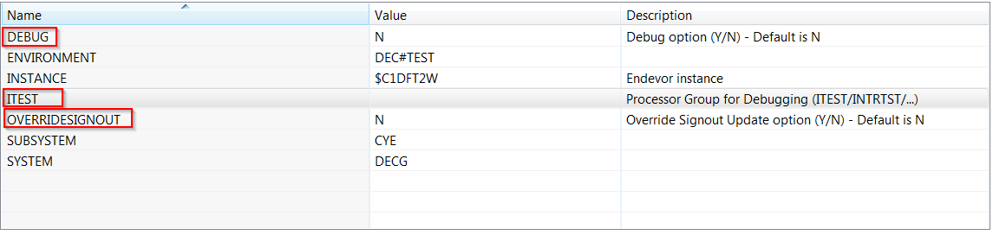

Developer may override these values when he requests a Build
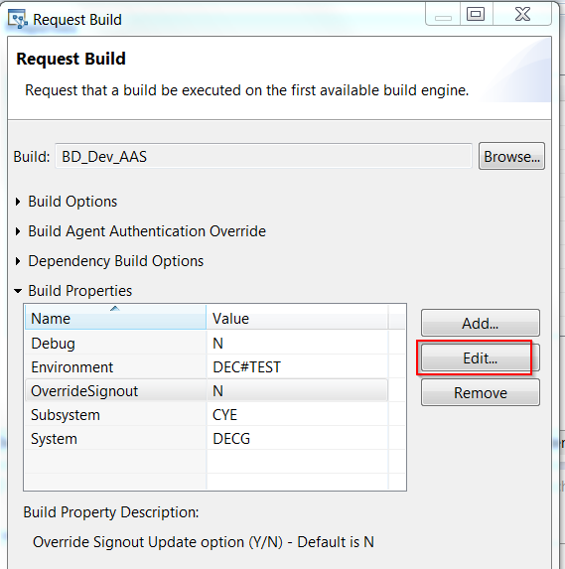

SCHENV (=LPAR parameter)

It is not needed by GCOMS, so it is on comment at the moment.
But will be needed for COP/GM*Drive/AAS

This will be managed on the Build Definition

Mainframe parameter

We will need to translate the Mainframe/LPAR information into DNS for the build engines.

This will be managed on the Build Engine.

Rexx scripts
A dedicated stream used for documentation purpose and Tools is created under GM_PA_ADM project. The TOOLS component contains the REXX scripts that are executed during the Build. These scripts are maintained in the stream ST_ADM_TOOLS from Project Area GM_PA_ADM
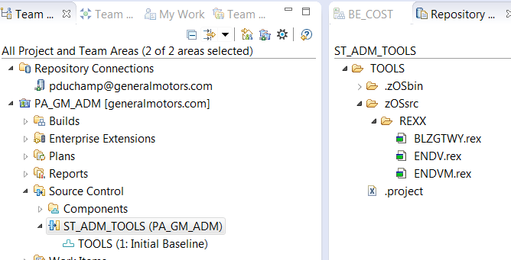

These REXX scripts are marked ‘Always load during a dependency build’
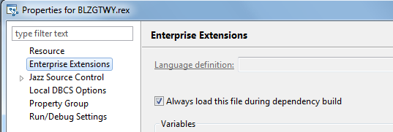
The component containing these scripts is called in the Stream from where Build can be requested.

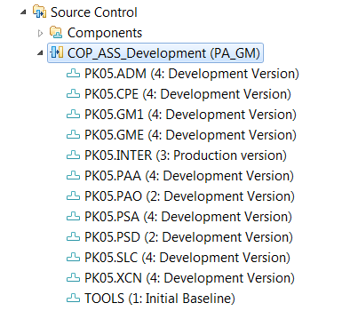

Association of a Language Definition
Each Buildable File must be associated to a Language Definition (equivalent of Type/Processor Group). That can be done in two ways.

With command line interface
RPP provides a dedicated command rpp-zcompmap

This command is used to map zComponent files and projects with language definitions or data set definitions. It is run from the Rational Team Concert™ source control command lines.
With this command, you define the artifacts that are required by the project, the zFiles COBOL files, and zFolder folders. You associate them with language definitions or data set definitions on the Rational Team Concert source control lines (scm). You can associate a language definition with zFile files or data set definitions with zFolder folders.
This command uses a mapping file for the association. The syntax of this file is the following
zFile#CobolProject\zOSsrc\Folder\Sample.cbl#LanguageDefinitionName

In order to build this mapping file, General Motors must provide, for each program and map:
- The external name
- The program type (Batch/Online/Map)
- The library code
- The Endevor Type

This tool will be used during the migration process

With RPP/RTC workstation
From the PDP Cobol Editor, you can associate a Language Definition to a program

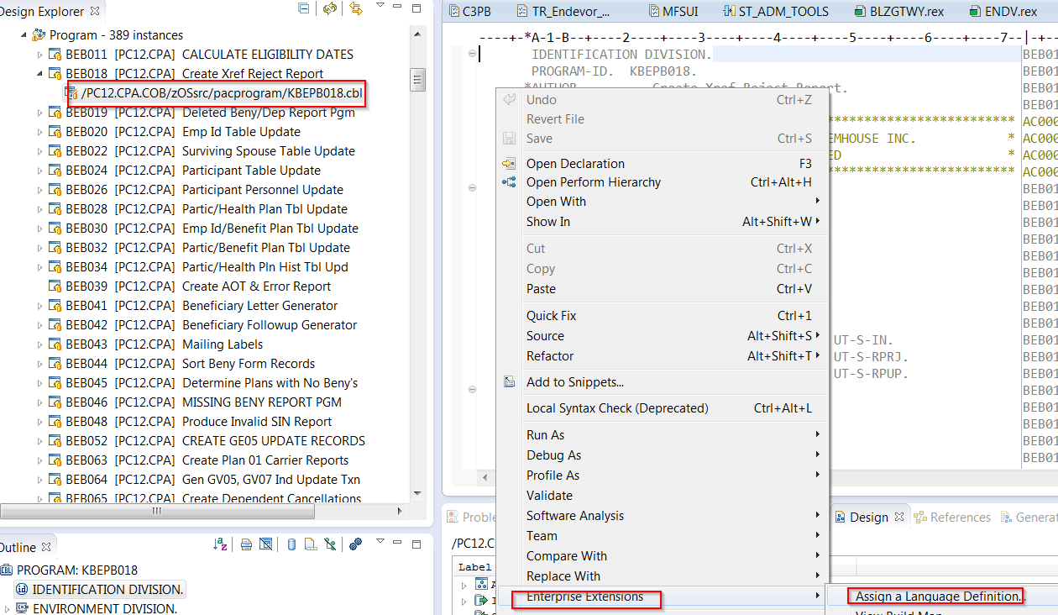

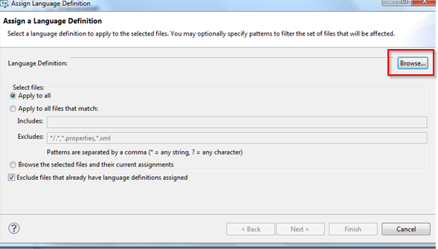
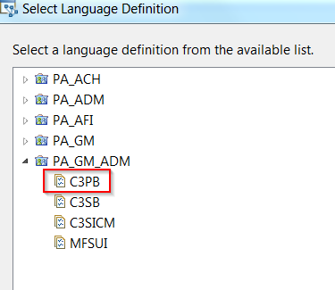

No the file is associated to a Language Definition and it inherites of the variable TYPE coming from the Language Definition.
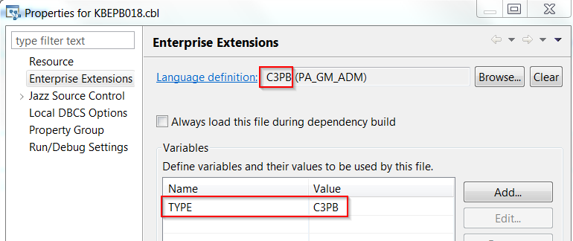

This possibility will be used for new programs, or to change the Endevor Type of an existing program.

Build Example

Build Request
There is two ways to run a Build

- Using subset
We create a subset artifact and include the program to build
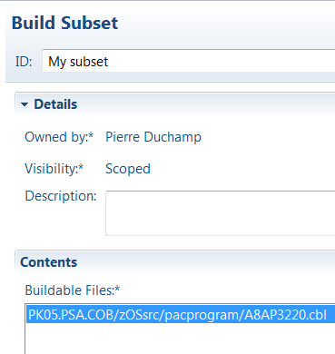

- Using Dependency Build

We run a build on the entire Repository Workspace. Only the files that have changed since the last build will be built

The program to build is associated to the Language Definition C3PB
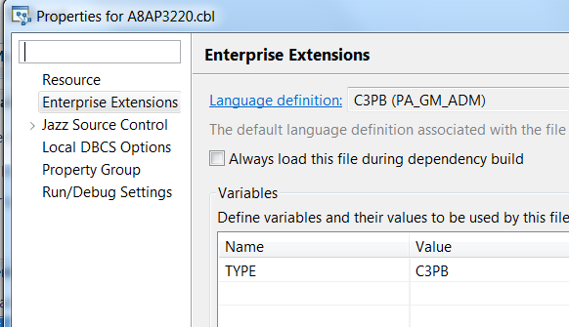

We request a build for AAS application

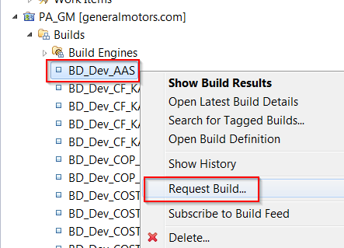

As we don’t have a valid userid on the Build Engine, it is necessary to enter a user/password when requesting the build

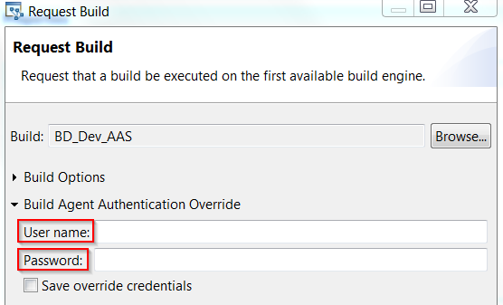
With possibility to save the credentials.

We specify the subset we want to build, or the Build dependency found the program to build.
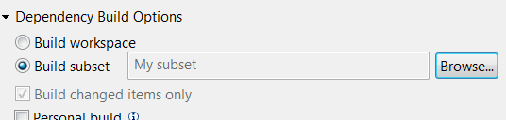
We inherit of the Endevor parameters specified on the Build Definition. We can override these parameters.
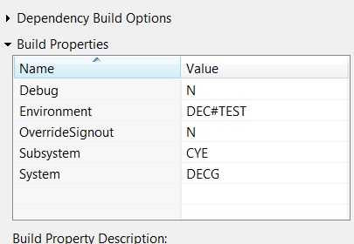
We submit the Build
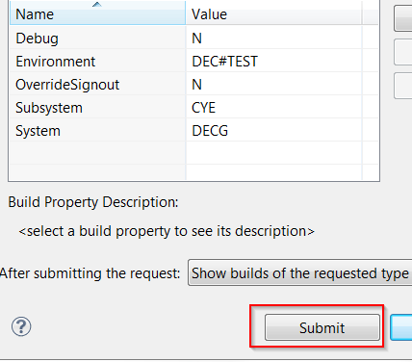

The rexx file defined on the translator will be executed, this rexx will submit an Endevor JCL.
The following variables will be passed to the JCL

"PROGRAM :" P1B
"PREFIX :" P2
"INSTANCE :" P3
"ENVIRONMENT :" P4
"SYSTEM :" P5
"SUBSYSTEM :" P6
"TYPE :" P7
"CCID :" P8
"COMMENTS :" P9
"DEBUG :" P10
"OVERRIDE SIGNOUT:" P11
"SCHENV :" P12
"DEBUG PROC GRP :" P13

Below the skeleton of this JCL.

//"run_USERID"BE JOB (NSEMP2),'GENERATE',CLASS=A,MSGCLASS=Y,
// NOTIFY=&SYSUID,REGION=0M
//* SCHENV='"P12"',
//*
//*************************************************
//* BATCH JCL STATEMENTS
//********************************************************
//NDVRBAT EXEC PGM=NDVRC1,DYNAMNBR=1500,REGION=0M,
// PARM='C1BM3000'
//STEPLIB DD DISP=SHR,DSN=SYS2.ENDEVOR.LOAD
//CONLIB DD DISP=SHR,DSN=SYS2.ENDEVOR.LOAD
//WAYNC1DF DD DISP=SHR,DSN=SYS2.ENDEVOR.LOAD("P3")
//IDIOPTS DD *
EXCLUDE
//SSN$XX DD DUMMY
//SYSPRINT DD SYSOUT=*
//********************************************************
//* SORT WORK FILES
//********************************************************
//SORTWK01 DD UNIT=SYSDA,SPACE=(CYL,(1,2))
//SORTWK02 DD UNIT=SYSDA,SPACE=(CYL,(1,2))
//SORTWK03 DD UNIT=SYSDA,SPACE=(CYL,(1,2))
//C1TPDD01 DD UNIT=SYSDA,SPACE=(CYL,5),
// DCB=(RECFM=VB,LRECL=260)
//C1TPDD02 DD UNIT=SYSDA,SPACE=(CYL,5),
// DCB=(RECFM=VB,LRECL=260)
//********************************************
//* PANVALET SUPPORT
//********************************************
//C1TPLSIN DD UNIT=SYSDA,SPACE=(CYL,5),
// DCB=(RECFM=FB,LRECL=80)
//C1TPLSOU DD UNIT=SYSDA,SPACE=(CYL,5)
//C1PLMSGS DD SYSOUT=*
//********************************************
//* OUTPUT DATA SETS
//********************************************
//C1MSGS1 DD SYSOUT=*
//C1MSGS2 DD SYSOUT=*
//C1PRINT DD SYSOUT=*,DCB=(RECFM=FBA,LRECL=133)
//SYSUDUMP DD SYSOUT=*
//SYMDUMP DD DUMMY
//SYSOUT DD SYSOUT=*
//*********************************************
//* REQUEST DATA SET
//*********************************************
//BSTIPT01 DD *
SET STOPRC 16 .
ADD ELEMENT '"P1B"'
FROM DSNAME '"P2".COBOL'"
TO ENVIRONMENT '"P4"' SYSTEM '"P5"' SUBSYSTEM '"P6"'
TYPE '"P7"'
OPTIONS CCID '"P8"'
UPDATE
.
**************************** Bottom of Data **************

Optional lines below will be added depending on parameters set:

PROC GROUP "P13" (Processor Group for Debugging, will be added if debugging flag is ‘Y’)
"P11B" (Override Signout, will be added if override flag is ‘Y’).

Then the rexx will catch the return code of the Job and will push the information in the Build Result
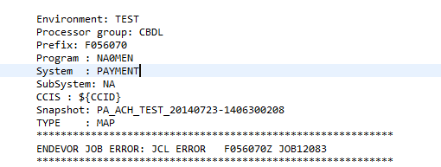

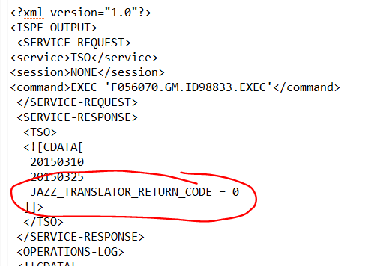

Annex A : Types/Processor Groups

GM*Drive
Types in Endevor (Processor Groups)
C3SB COBOL BATCH SUBROUTINES
C3SICM COBOL SUBROUTINE IMS/CICS
C3SIC2 COBOL SUBROUTINE IMS/CICS/DB2 DYN
C3SIC2N COBOL SUBROUTINE IMS/CICS/DB2 NODYN
C3SID2 COBOL DB2/IMS SUBROUTINES
C3STD2 COBOL TSO/SUBROUTINES WITH DB2
C3PB COBOL BATCH PROGRAM
C3PCD2 COBOL CICS/DB2
C3PID2 COBOL DB2/IMS ONLINE
C3PTD2 COBOL TSO WITH DB2
S3PTD2 COBOL TSO WITH DB2 SHARED LOAD TO ESDS
DBD PRODUCTIVE DBD
PSB PRODUCTIVE PSB
ACBIMS PRODUCTIVE ACB
MFSUI PRODUCTIVE MFS

COP
Types in Endevor (Processor Groups)
C3SB COBOL BATCH SUBROUTINE
C3SID2 COBOL DB2/IMS ONLINE SUBROUTINES
C3STD2 COBOL TSO/SUBROUTINES WITH DB2
C3PB COBOL BATCH
C3PTD2 COBOL TSO/BATCH WITH DB2
DBD PRODUCTIVE DBD
PSB PRODUCTIVE PSB
ACBIMS PRODUCTIVE ACB
MFS PRODUCTIVE MFS

AAS
Types in Endevor (Processor Groups)
C3SID2 COBOL DB2/IMS ONLINE SUBROUTINES MOD.OFF.
C3SIIM COBOL IMS ONLINE SUBROUTINE MOD.OFF.
C3PID2 COBOL DB2/IMS ONLINE MOD.OFF.
C3PB COBOL BATCH MOD.OFF.
C3PTD2 COBOL DB2/TSO MOD.OFF.
S3PTD2 COBOL DB2/TSO SHARED LOAD MOD.OFF.
PSB PRODUCTION PSB MOD.OFF.
ACBIMS PRODUCTION ACB MOD.OFF.
MFS PRODUCTIVE MFS IMS MOD.OFF.

COST (Finance)
Types in Endevor (Processor Groups)
C3SIIM COBOL MVS IMS ONLINE SUBPROGRAMS/IMS DB
C3PIIM COBOL MVS IMS ONLINE/IMS DB
C3PB COBOL MVS BATCH
C3PBIM COBOL MVS IMS BATCH

CF (Corporate Functions)
Types in Endevor (Processor Groups)

C3PB COBOL MVS BATCH
C3PBI2 COBOL MVS DB2/IMS BATCH
C3PTD2 COBOL MVS DB2/TSO
C3PBIM COBOL MVS IMS BATCH
C3SID2 COBOL MVS DB2/IMS ONLINE SUBPROGRAMS
C3PIIM COBOL MVS IMS ONLINE/IMS DB
C3SIIM COBOL MVS IMS ONLINE SUBPROGRAMS/IMS DB
DCLTD2 DB2 BIND ONLY (USING DB2 OPTIONS ONLY)

VTIMS
Type Description

MFS IMS MESSAGE FORMAT SERVICES
CL TSO CLIST
C3STD2 BATCH PACBASE COBOL OS/390 SPGM ALL DB2 RMT SITE
C3STD2$ BATCH PACBASE COBOL OS/390 SPGM ALL WITH DB2
C3SBI2 BATCH PACBASE COBOL OS/390 SPGM ALL DB2 MSC LINK
C3SID2 ONLINE PACBASE COBOL OS/390 SUBPGM MPP WITH DB2
C3PB BATCH PACBASE COBOL OS/390 DRIVER BATCH
C3PBIM BATCH PACBASE COBOL OS/390 DRIVER DLI
C3PIIM ONLINE PACBASE COBOL OS/390 DRIVER MPP
C3PID2 BATCH PACBASE COBOL OS/390 DRIVER MPP WITH DB2
C3PBI2 BATCH PACBASE COBOL OS/390 DRIVER DLI WITH DB2
C3PBI2$ BATCH PACBASE COBOL OS/390 DRIVER BMP WITH DB2
C3PTD2$ BATCH PACBASE COBOL OS/390 DRIVER BATCH WITH DB2
DCLID2BO DB2 PACKAGE LIST BINDS FOR ONLINES
DCLTD2BB DB2 PACKAGE LIST BINDS FOR BATCH
JCL JCL BATCH (THROUGH JOBSCAN)
JCLJ RJE, RELEASE JCL
C3PTD2 DB2 STORED PROCEDURES COBOL
C3PID2Q BATCH COBOL OS/390 DRIVER MPP WITH DB2 MQ SERIES
PSB IMS PSB
DDLTD2 DB2 GRANT

GCOMS
Type Description
MFS IMS MESSAGE FORMAT SERVICES
REXX TSO REXX
SPC ISPF CLIST
SPG ISPF MESSAGES
SPK ISPF SKELETONS
SPU ISPF PANELS
C2YL COBOL II ++INCLUDES
C2YY COBOL II COPY MEMBERS
DAYL ++INCLUDE MEMBERS
FCY FOCUS MASTER (COPY BOOKS)
P2YL PL/I V2 ++INCLUDE MEMBERS
LDPB LOAD MODULE ONLY BATCH
LDPI LOAD MODULE ONLY IMS/DC
LDPICG LOAD MODULE ONLY IMS/DC
LDPID2$ NO SOURCE; SPECIAL COOL GEN PROCESS
PSB IMS PSB
AHSB ALC BATCH SUBPROGRAMS
AHSBIM ALC IMS BATCH SUBPROGRAMS
C2SB COBOL II BATCH SUBPROGRAMS
C2SID2 COBOL II DB2/IMS ONLINE SUBPROGRAMS
C2SIIM COBOL II IMS ONLINE SUBPROGRAMS/IMS DB
C3SID2 COBOL MVS DB2/IMS ONLINE SUBPROGRAMS
C3SIIM COBOL MVS IMS ONLINE SUBPROGRAMS/IMS DB
P2SB PL/I MVS BATCH SUBPROGRAMS
P2SBIM PL/I MVS IMS BATCH SUBPROGRAMS
P2SBI2 PL/I MVS DB2/IMS BATCH SUBPROGRAMS
P2SID2 PL/I MVS DB2/IMS ONLINE SUBPROGRAMS
P2SIIM PL/I MVS IMS ONLINE SUBPROGRAMS/IMS DB
P2STD2 PL/I MVS DB2/TSO SUBPROGRAMS
AHPB ALC BATCH
C2PB COBOL II BATCH
C2PBIM COBOL II IMS BATCH
C2PBI2 COBOL II DB2/IMS BATCH
C2PID2 COBOL II DB2/IMS ONLINE
C2PTD2 COBOL II DB2/TSO
C3PB COBOL MVS BATCH
C3PBIM COBOL MVS IMS BATCH
C3PBI2 COBOL MVS DB2/IMS BATCH
C3PID2 COBOL MVS DB2/IMS ONLINE
C3PTD2 COBOL MVS DB2/TSO
EZPB EASYTRIEVE PLUS
E6PB EASYTRIEVE PLUS 6.2
P2PB PL/I MVS BATCH
P2PBIM PL/I MVS IMS BATCH
P2PBI2 PL/I MVS DB2/IMS BATCH
P2PID2 PL/I MVS DB2/IMS ONLINE
P2PIIM PL/I MVS IMS ONLINE/IMS DB
P2PS PL/I MVS ISPF
P2PTD2 PL/I MVS DB2/TSO
FCNB FOCUS INTERPRETIVE BATCH
SYSIN CONTROL OR INPUT CARDS
SYSINAD CONTROL OR INPUT CARDS ADELAIDE
SYSINRU CONTROL OR INPUT CARDS RUSSELHEIM
SYSINUT CONTROL OR INPUT CARDS UAT
DOC DOCUMENTATION
DOCWO WORD DOCUMENTATION
DOC255 DOCUMENTATION - 255 BYTES
PROC JCL PROCEDURES (CATALOGED)
PROCAD JCL PROCEDURES (CATALOGED) ADELAIDE
PROCRU JCL PROCEDURES (CATALOGED) RUSSELHEIM
PROCUT JCL PROCEDURES - SKELETON PROCS
JCL JCL BATCH (THROUGH JOBSCAN)
JCLAD JCL ADELAIDE
JCLRU JCL RUESSELSHEIM
JCLUT JCL UAT TESTING
C3PTD2$G COBOL BATCH PROGRAMS WITH DB2 FOR GPS BINDING
C3PID2Q COBOL II DB2/IMS ONLINE MQ SERIES
RMTLIB ADVANTAGE: GEN
DBRM DBRM Code
DCLTD2$ db2 bind plan only (using db2 options only)
DCLTD2 db2 bind package only (using db2 options only)
LINKCARD LINK CONTROL CARDS

