RDz 9.1.1 – z/OS Search does not indicate that search is not allowed

There are a number of libraries where I do not have access to. Below a screenshot indicating that I am not allowed to access GBCNA.WERK.CNTL.

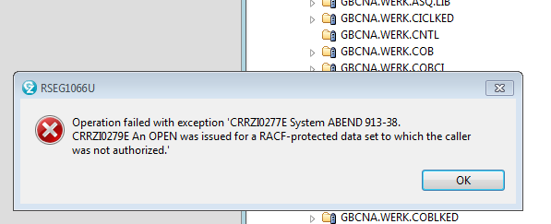

When I perform a search on that PDS, looking for a string in a member, the search appears to have been executed. 0 results are returned.

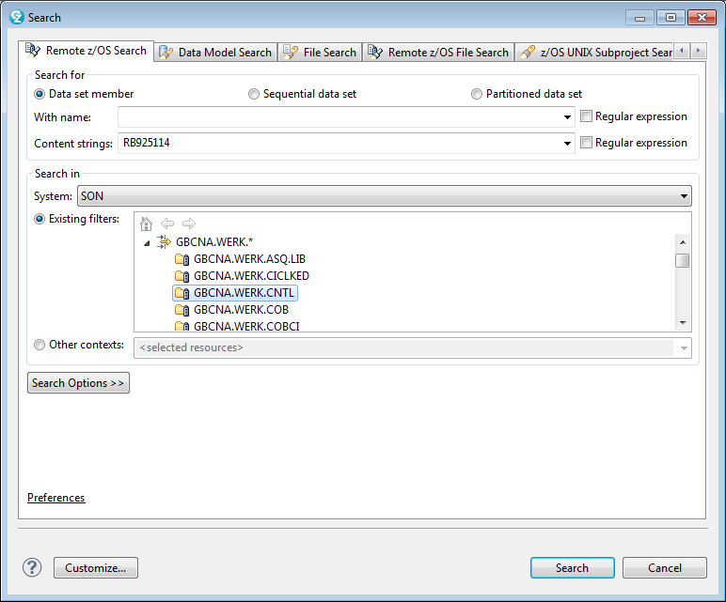

The Remote z/OS Search view indicates 0 hits.

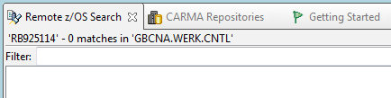

I can perform the same search using the 3.14 option under ISPF.

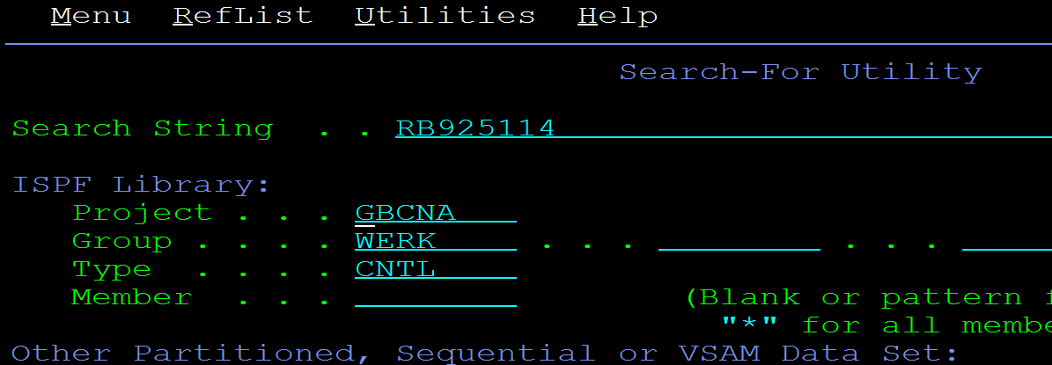

This results in a message indicating that there is insufficient access authority.

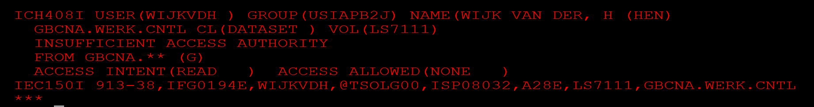

In RDz I would expect a similar handling of the situation.