The C++ remote editor automatic search of occurrences (obtained by a click or double click) works only with simple variables. Function, elements pointed are ignored.
Ex:1 : all instances of oErreur are highlighted | 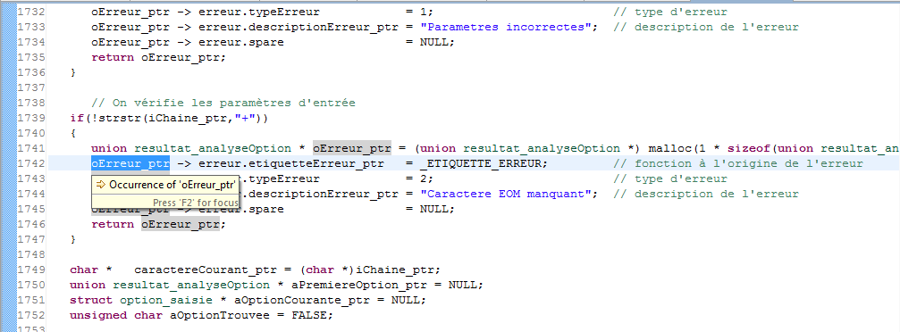
Ex:2  erreur is pointed, but the other occurrences are not highlighted | 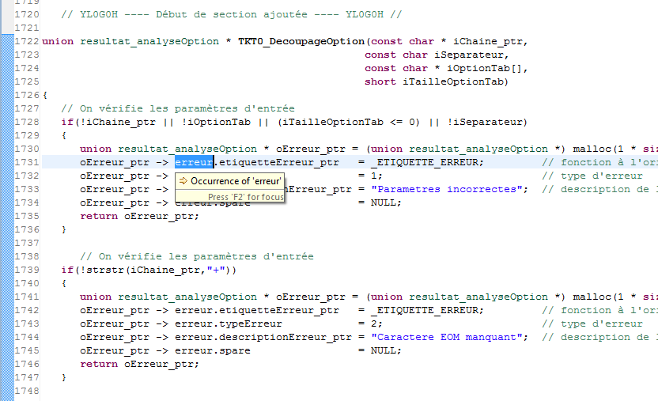
Ex: 3  the other instances of the malloc function are ignored. | 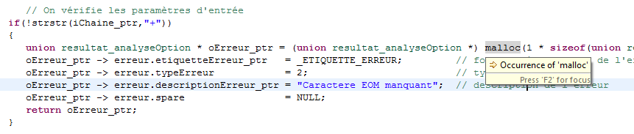
Ex4:  Structure elements are not found | 