For this case below, table AXXYY was catalogued in upper case the same was entered in FM pluing client, but it didn’t retrieve.

Catalog details:

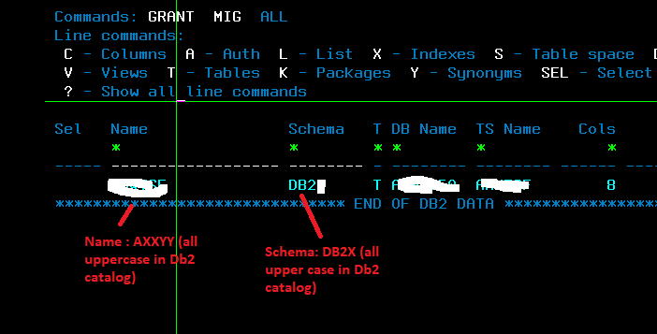

FM client:

