If you see below screen from SQ, it is showing some tips/insight to the developers for the respective issue and how to correct it.

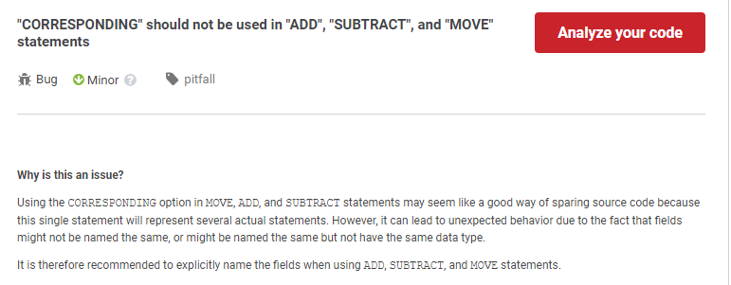
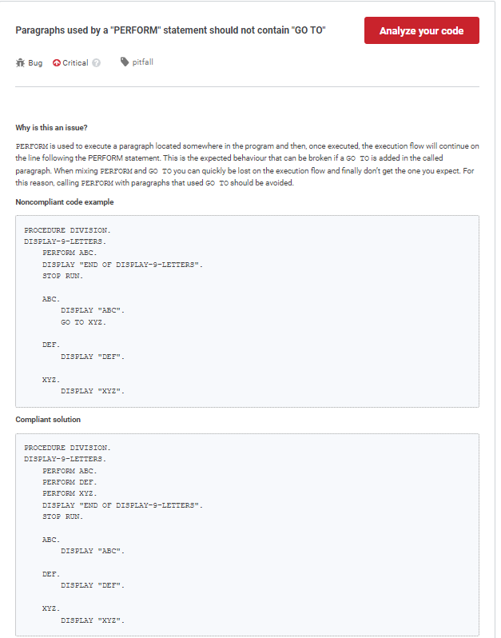

Is that possible to provide that kind of information when I clicked on the SA error in IDZ?

