Back in previous ADDI versions (before v611) we have been having ADDI legend icon under AD Analyze client within the visible menu bar. Like below:

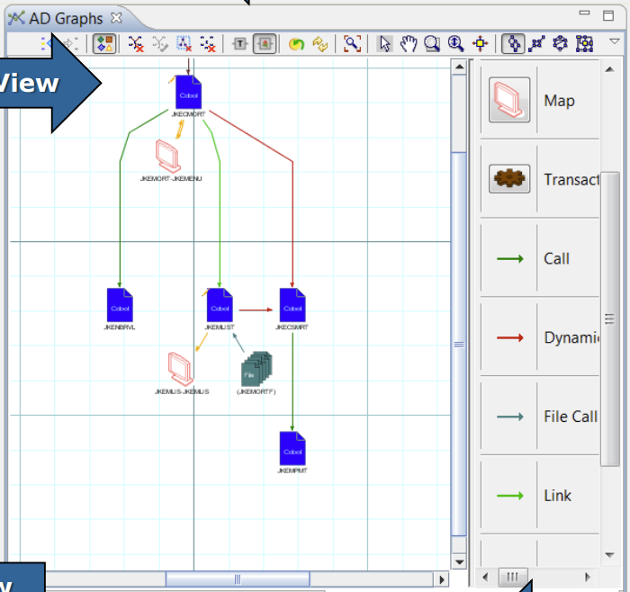

The Legend icon was possible to click and then to see legend items on the right hand side. That was very convenient.

Under new ADDI v611 Analyze client we do get it shown under expandable menu (when using three dots):

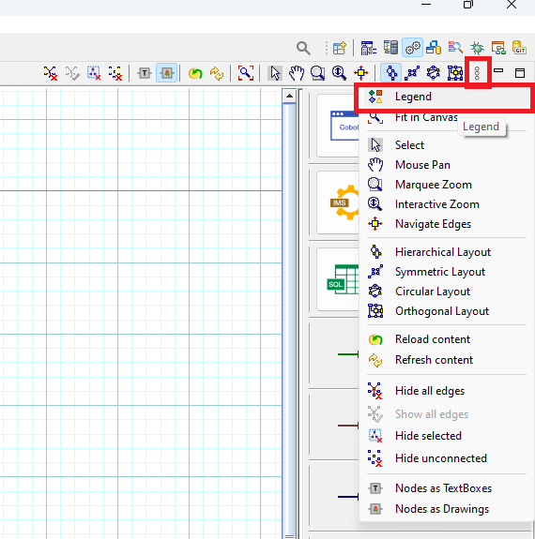

We have got a feedback from our development community that this new way of doing thing is not very convenient and they would like to get Legend icon back into the visible menu bar. Question here is if we can configure this anywhere under AD Analyze plug-in to make legend appearing the same way as it was in the previous AD versions?