Jamie,
We have tried to automate MQSC0347E.
Our experience has been mixed, frustrating, and inconsistent.
First automation is faced with reading a z/TPF Message Number that spans multiple lines.
For us, the message is physically 5 lines which automation must parse. The first CSMP line tells us which CPU the commands must be entered from.
Second, we have encountered situations where of the 5 lines are not consecutive. The attached console file (COM1228.LTC) shows examples (Line 1673, Line 1680).

Thirdly, when we enter the single ZMQSC RESET CHL-OTPAQG02.A1PATE01.01 SEQNUM-10158 command, we have encountered MQSC0324E Channel is in Use error conditions.
<--End //SMPAZMQSC RESET CHL-OTPAQG02.A1PATE01.01 SEQNUM-10158--><0.00>
<--Start //SMPAZMQSC RESET CHL-A1PATA02.A1PATE01.01 SEQNUM-77213-->
CSMP0097I 18.18.17 CPU-A SS-BSS SSU-1P1P IS-01
MQSC0324E 18.18.17 CHANNEL - A1PATA02.A1PATE01.01 IS IN USE

As a result, the automation mushrooms into even more complications. Now we must enter 3 separate commands, wait on the response for each, and parse and validate each response for success.
ZMQSC STOP CHL-
ZMQSC RESET CHL-
ZMQSC START CHL-

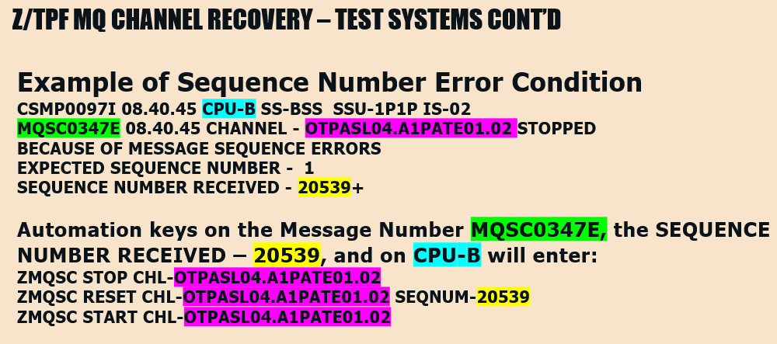
This is why we yearn for a simple single MQ Receiver Channel command that says accept the next message sequence number received.

