This is the screenshot with the drilldown options I am reffering to: 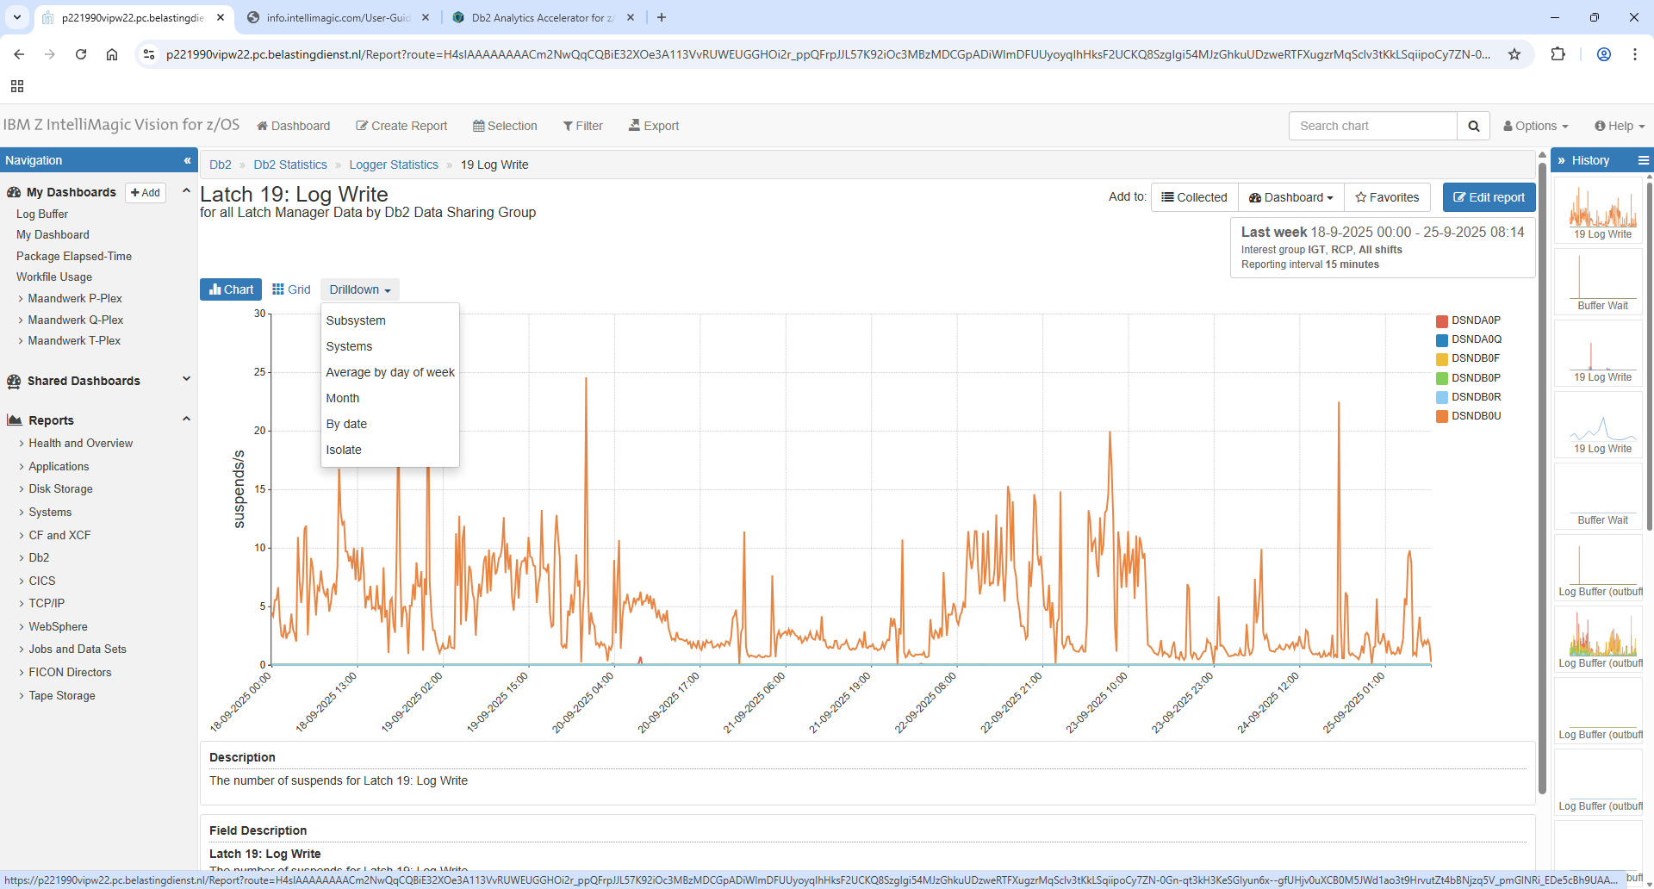
And this is the drilldown option I have for he report I created: 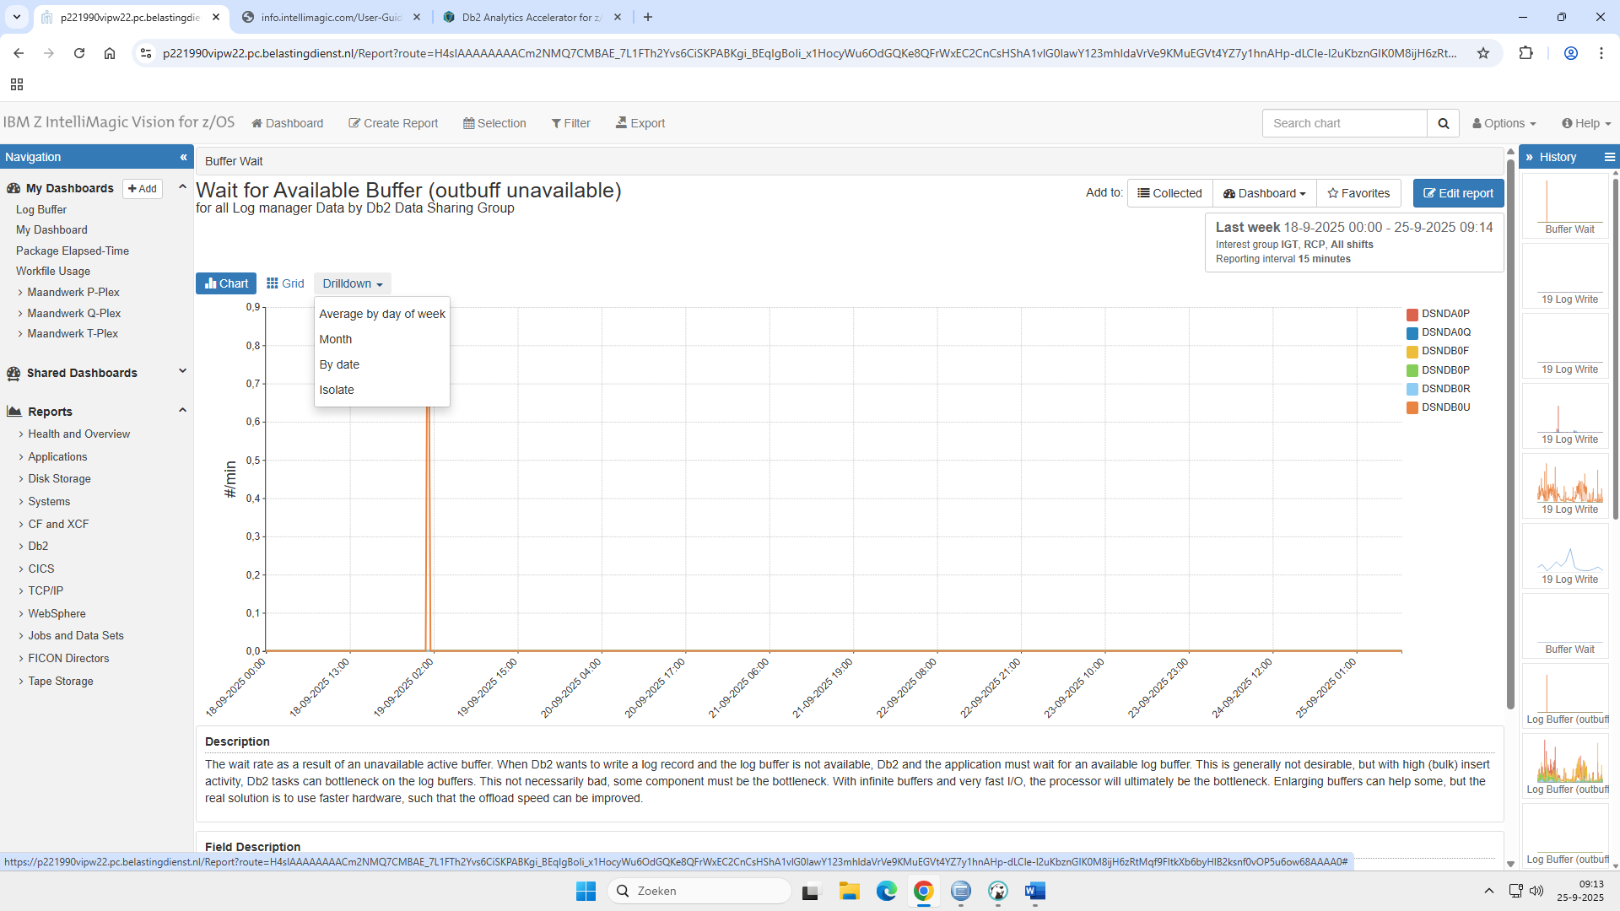
Here the definitions of my report: ( I used the CREATE report option at the top of the screen)
