I have the same issue in both Chrome and Edge. If I’m in the Report view it displays as expected, but if I’m in a Dashboard it covers the “Collected” heading. I’ve included an example of both below so you can see which view is working correctly and which is not.

Dashboard: (BAD)
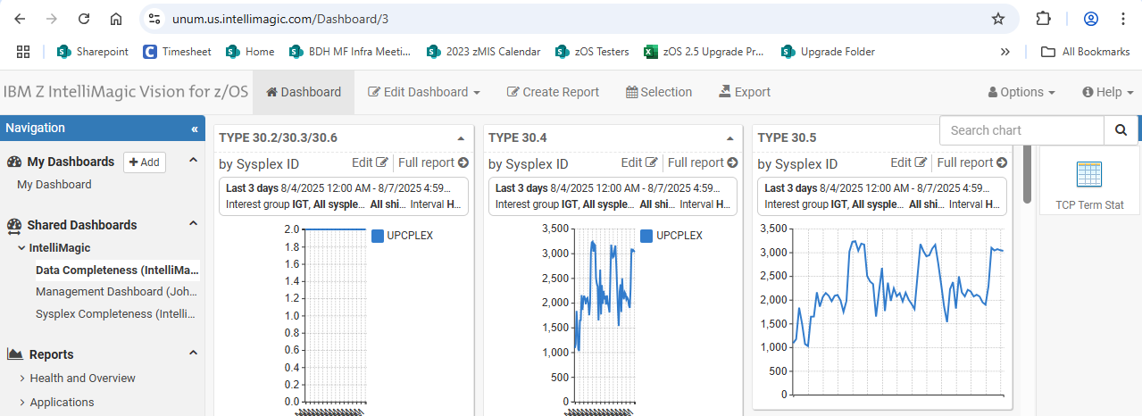

Report: (GOOD)

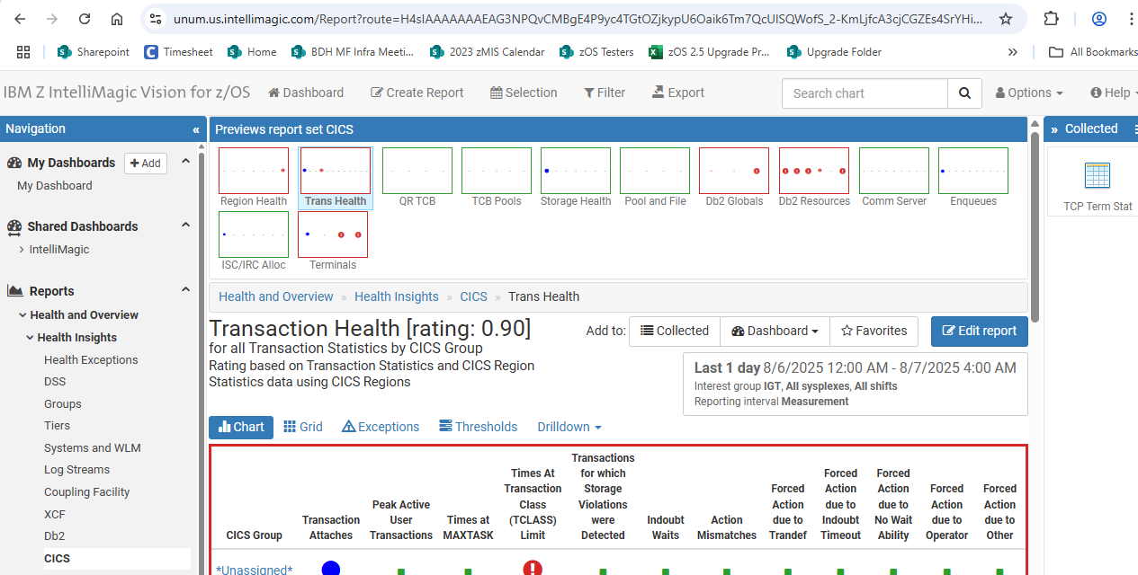
From: Brian Reutzel <Brian.Reutzel@ibm.com>
Sent: Thursday, August 7, 2025 5:11 PM
To: Bowden, Stacie <SBowden@UNUM.COM>; Anna Casemier <Anna.Casemier@ibm.com>; Jeff Lane <JEFFREY.LANE@ibm.com>
Subject: RE: Location of Search box?

Stacie, Mine is still good and I don’t think we can move these items around. Looks more like a browser issue. Please try in a different browser or restart. Thanks, Brian Reutzel Senior Consultant IBM Z IntelliMagic Vision for z/OS https: //www. ibm. com/products/z-intellimagic-vision-for-zos

Stacie,
Mine is still good and I don’t think we can move these items around.

Looks more like a browser issue.
Please try in a different browser or restart.

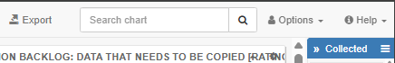

Thanks,

Brian Reutzel
Senior Consultant
IBM Z IntelliMagic Vision for z/OS
https://www.ibm.com/products/z-intellimagic-vision-for-zos

From: Bowden, Stacie <SBowden@UNUM.COM>
Sent: Thursday, August 7, 2025 3:41 PM
To: Anna Casemier <Anna.Casemier@ibm.com>; Brian Reutzel <Brian.Reutzel@ibm.com>; Jeff Lane <JEFFREY.LANE@ibm.com>
Subject: [EXTERNAL] Location of Search box?
Hi All The location of the Search Chart box in my Dashboard seems odd – it’s covering the “Collected” section title. How can I move it higher – possibly between “Export” and “Options” in
Hi All
The location of the Search Chart box in my Dashboard seems odd – it’s covering the “Collected” section title. How can I move it higher – possibly between “Export” and “Options” in the header?
Thanks
Stacie

